CSE 490 –Switch Configuration

ID
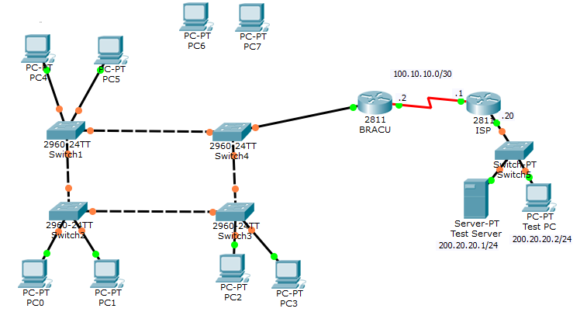
VLANs /Devices | VLAN 10 (HR) | VLAN 20  (Sales) | VLAN 100  Management | IP Address | Trunk Ports
Switch 1 | Fa0/6– Fa0/11 | Fa0/12 – Fa0/17 |  | 192.168.1.17/28  Gateway: 192.168.1.21/28 | Fa0/1-0/5
Switch 2 | Fa0/6– Fa0/11 | Fa0/12 – Fa0/17 |  | 192.168.1.18/28 | Fa0/1-0/5
Switch 3 | Fa0/6– Fa0/11 | Fa0/12 – Fa0/17 |  | 192.168.1.19/28 | Fa0/1-0/5
Switch 4 | Fa0/6– Fa0/11 | Fa0/12 – Fa0/17 |  | 192.168.1.20/28 | Fa0/1-0/5
PC0 | 192.168.1.98/28  Gateway: 192.168.1.100/28
PC1 |  | 192.168.1.130/28  Gateway: 192.168.1.132/28
PC2 | 192.168.1.99/28  Gateway: 192.168.1.100/28
PC3 |  | 192.168.1.131/28  Gateway: 192.168.1.132/28
PC4 | 192.168.1.97/28  Gateway: 192.168.1.100/28
PC5 |  | 192.168.1.129/28  Gateway: 192.168.1.132/28
Pre configuration:
No configuration is required for the ISP Router and Test PC and Test Server.

Objective
Task 1: Configuration
Note: Please follow the steps.
- Configure the name of Switch1 to Switch1.
- Configure and Switch1 with console and vty passwords of “cisco”.
- Create and name the VLANs shown in the table and assign vlans to ports according to the table shown in Switch 1 only.
- Also configure the necessary ports trunk and assign the appropriate native/management vlan to the trunk port.
- Set the IP address and default gateway for Switch1 shown in the table.
- Enable switch port security to ports range 6 to 11. (Maximum 2 and enable sticky)
- Check connectivity between PCs of same vlans.
- Configure VLAN trunking (sub-unterfaces) required in the router BRACU.
- Check connectivity between PCs of different vlans and from the PCs to the Server at 200.20.20.1.
- Disconnect PC4 from port fa0/6. Now connect PC6 to port fa0/6, and test connectivity to the Server. Then do the same for PC7. What happens?

_______________________________________________________________________________

Task 2: Observations
- What is the violation mode of port fa0/6?

__________________________________________________________________________________

- Find the root switch. Why is it the root switch?

__________________________________________________________________________________
- Which switch’s port is blocked?

__________________________________________________________________________________

- What is the path cost of the ports fa0/1 and fa0/2 of Switch 1?

__________________________________________________________________________________

